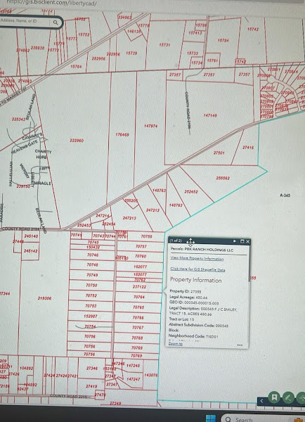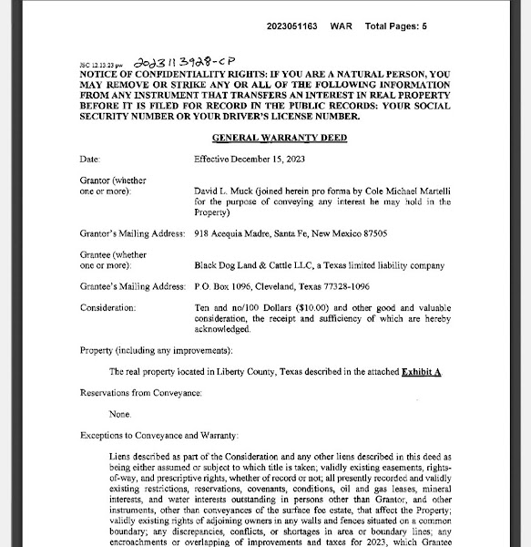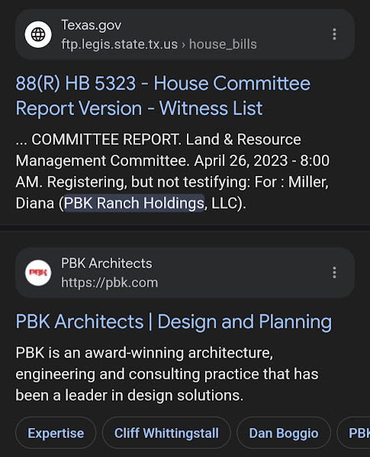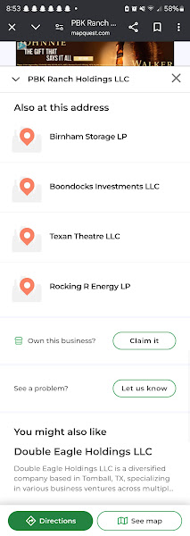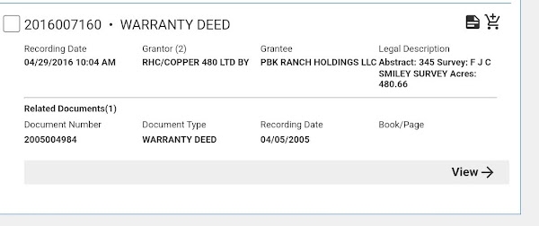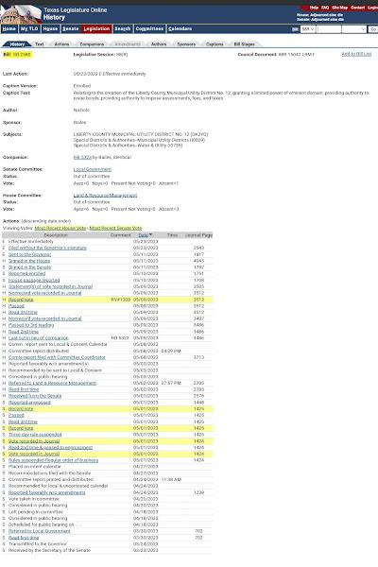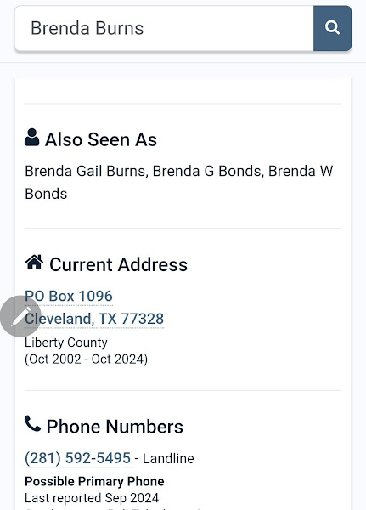

Tom johnson

P.O. Box 1096 Cleveland, TX 77328

Qualified DOT contractors
Encino Landscape Inc
5631 County Road 2185, Cleveland, TX 77327-9598

President for Black Dog Land & Cattle LLC
Shepherd,Tx

M-Club
93-1956613 EIN

Tom L Johnson
3190 Fm 223 Rd
Shepherd, TX 77371

Johnson Construction Clearing LLC
Olan S Johnson
16192 Fm 787 Rd W Cleveland, TX 77327
Po box 1242
Cleveland texas 77328

Kevin Johnson
Po box 1242
Cleveland texas 77328

https://www.choctawranchhunting.com/
Choctaw ranch hunting
3478 Hwy 59 North
Freer, Texas 78357

Pbk Holdings LLC - land acquisition company
9522 FM 2920 Rd
Tomball, TX 77375

Texan Theater LLC
9522 FM 2920 Rd
Tomball, TX 77375

Rocking R Energy
9522 FM 2920 Rd
Tomball, TX 77375

Birnham storage LP
9522 FM 2920 Rd
Tomball, TX 77375

Boondocks investments LLC
9522 FM 2920 Rd
Tomball, TX 77375

Pbk holdings - MUD #12
Texas HB5323
Mentions Doc #2016007160
Abstract: 345 Survey: F J C SMILEY SURVEY Acres: 480.66

1 of 1

Parcels: WHITTON CARROL DELANE 'BO' & CAROLYN R
View More Property Information

Property Information

Property ID: 95417

Legal Acreage: 4.89

GEO ID: 000345-000214-000

Legal Description: 000345 F J C SMILEY, TRACT 214, ACRES 4.8949

Tract or Lot: 214

Abstract Subdivision Code: 000345

Block:

Neighborhood Code: TISD01

School District: STA

City Limits:

Property Location

Situs Number: 351

Situs Street Prefix:

Situs Street Name: ORR LN

Situs Street Sufix:

Situs City: CLEVELAND

Situs State: TX

Situs Zip: 77327

Owner Information

Owner Name: WHITTON CARROL DELANE 'BO' & CAROLYN R

Mailing Address: 351 ORR LN

Mailing Address City: CLEVELAND

Mailing Address State: TX

Mailing Address Zip: 77327

**Fully Restored and Expanded Comprehensive List**

### **Elected Officials & Government Representatives**

#### **Liberty County Officials**
- **Jay Knight** – County Judge, 1923 Sam Houston St., Liberty, TX 77575, (936) 336-4665.
- **Lee Haidusek Chambers** – County Clerk, 1923 Sam Houston St., Liberty, TX 77575, (936) 336-4670.
- **Matthew Poston** – County Attorney, 1923 Sam Houston St., Liberty, TX 77575, (936) 336-4650.
- **Richard Brown** – County Tax Assessor-Collector, 1923 Sam Houston St., Liberty, TX 77575, (936) 336-4633.

#### **City of Cleveland Officials**
- **Danny Lee** – Mayor, 907 E. Houston St., Cleveland, TX 77327, (281) 592-2667.
- **Marilyn Clay** – Councilmember Position 1, 907 E. Houston St., Cleveland, TX 77327, (281) 592-2667.
- **Fred Terrell** – Councilmember Position 2, 907 E. Houston St., Cleveland, TX 77327, (281) 592-2667.
- **Carolyn McWaters** – Councilmember Position 3, 907 E. Houston St., Cleveland, TX 77327, (281) 592-2667.
- **Delores Terry** – Councilmember Position 4, 907 E. Houston St., Cleveland, TX 77327, (281) 592-2667.
- **James Franklin** – Councilmember Position 5, 907 E. Houston St., Cleveland, TX 77327, (281) 592-2667.

#### **City of Liberty Officials**
- **Carl Pickett** – Mayor, 1829 Sam Houston St., Liberty, TX 77575, (936) 336-3684.
- **Libby Simonson** – Mayor Pro Tem, 1829 Sam Houston St., Liberty, TX 77575, (936) 336-3684.
- **Diane Driggers** – Councilmember, 1829 Sam Houston St., Liberty, TX 77575, (936) 336-3684.

### **Tarkington Independent School District (TISD) Board Members**
- **Paige Bostwick** – Place 1, pbostwick@tarkingtonisd.net.
- **Susan Rollins** – Place 2, srollins@tarkingtonisd.net.
- **Kevin Johnson** – Place 3, kbjohnson@tarkingtonisd.net.
- **Dwayne Stovall** – Place 4, dstovall@tarkingtonisd.net.
- **Jason Ward** – Place 5, jward@tarkingtonisd.net.
- **Jackie Flores** – Place 6, jflores@tarkingtonisd.net.
- **Lane Gulledge** – Place 7, lgulledge@tarkingtonisd.net.

### **Key Developers & Business Owners**
- **John Harris** – Developer, Colony Ridge, Liberty County, TX.
- **Trey Harris** – Developer, Colony Ridge, Liberty County, TX.
- **Jimmy Rollins** – Property & Business Owner, Ann Holhousen League, TX.
- **Susan Rollins** – Property & Business Owner, Ann Holhousen League, TX.
- **Melanie Kay Hunter** – Property Owner, 12716 FM 787 Rd W, Cleveland, TX.
- **Shianne Grace Hunter** – Property Owner, 12716 FM 787 Rd W, Cleveland, TX.
- **Raymond Olen Beasley** – Previous Property Owner, 12716 FM 787 Rd W, Cleveland, TX.
- **Tom Johnson** – Business/Property Owner.
- **Kevin Johnson** – Business/Property Owner.
- **Brenda Johnson** – Business/Property Owner.
- **Kenneth 'Kenny' Burns Sr.** – Principal of Burns Architecture, LLC.
- **Brenda G. Burns** – Business/Property Owner, potential ties to Burns Architecture, LLC.
- **Mary Darlene Burchett** – Business/Property Owner.
- **Bergman Harkness** – Business Owner.
- **Kerri Helms** – Business Owner.
- **Nikki Helms** – Business Owner.
- **Niki J. Helms** – Business Owner.
- **Nikki Thompson** – Business Owner.
- **William Evans** – Business Owner.
- **Jessica Clancy** – Business Owner.
- **Laverne Hamilton** – Business Owner.
- **Justin L. Helms** – Business Owner.
- **Katelyn B. Helms** – Business Owner.
- **Olan S. Johnson** – Business Owner.

### **Businesses & Entities of Interest**
- **HGS Roofing & Siding Inc.** – Abstract: 354, B. Tarkington Survey, Acres: 1.635.
- **2045 Realty LLC** – Real Estate Holding, Abstract: 384, T&NO Railroad Survey, Acres: 25.55.
- **JD Lazor Enterprises Inc.** – Business, Survey: Stephen Nicholson.
- **First Bank & Trust East Texas** – Financial Institution, Multiple Branches in East Texas.
- **Prosperity Bank** – Financial Institution, Multiple Branches in Texas.
- **Oak Creek Homes LP** – Housing Development, Survey: Maurice Smith League.
- **Energy Transfer GC NGL Pipelines LP** – Energy Company, Abstract: 805, George L. Pace Survey, Acres: 31.165.
- **Rollins Real Estate** – Business, Ann Holhousen League, TX.
- **Encino Landscape, Inc.** – Business potentially tied to county contracts.
- **Black Dog Land & Cattle LLC** – Business.
- **M-Club** – Business.
- **Tom L. Johnson** – Business.
- **Johnson Construction Clearing LLC** – Business.
- **Choctaw Ranch Hunting** – Business.
- **PBK Holdings LLC** – Business.
- **Texan Theater LLC** – Business.
- **Rocking R Energy** – Business.
- **Birnham Storage LP** – Business.
- **Boondocks Investments LLC** – Business.
- **PBK Holdings - MUD #12** – Business.

### **Political & Advocacy Groups**
- **Protect and Serve Texas PAC**
- **Donald Baker** – Advisory Board Member, Austin, TX.
- **Eric Borton** – Treasurer & Advisory Board Member, Arlington, TX.
- **Jimmy Rodriguez** – Advisory Board Member, San Antonio, TX.
- **Dade Phelan** – Texas House Speaker, Major Donor ($193,901).
- **Houston Region Business Coalition** – Major Donor ($140,000).

### **Key Investigative Areas**
- **Potential Conflicts of Interest** in government contracts, business dealings, and dual office holdings.
- **Property transactions & ownership overlaps** involving Liberty County officials and developers.
- **Campaign finance records & political contributions** that may indicate undue influence.
- **Legal violations & misconduct** related to a September 16, 2024, incident at Tarkington High School.
- **Financial activities & contract awards** involving Burns Architecture, Encino Landscape, and PBK Ranch Holdings LLC.

### **Ongoing Research Priorities**
1. **Further connections between the Campbell, Beasley, Rollins, and Hunter families** in real estate and political contributions.
2. **Analysis of zoning, land acquisition, and development practices** in Liberty County.
3. **Investigation into procurement records** for public contracts awarded to businesses with potential conflicts of interest.

This report is continually updated to incorporate all newly discovered individuals, businesses, and investigative findings.

